Day 4 - Create Groups and Apply AGDLP
- **Promote the server to the first DC of a new forest.**

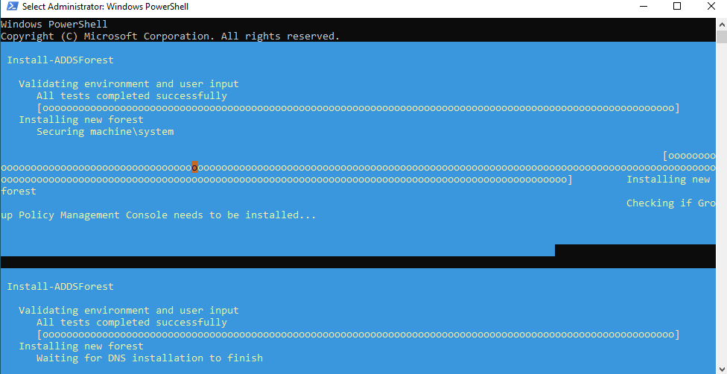
Once the ADDS Forest was installed, it will sin me out and login as the admin
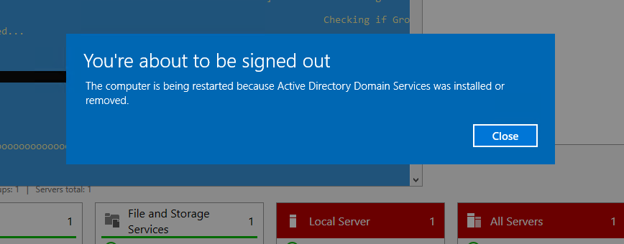
**Verify the forest is healthy:**
dcdiag /v
is a Domain Controller diagnostic command used to perform a detailed health check of a Domain Controller.
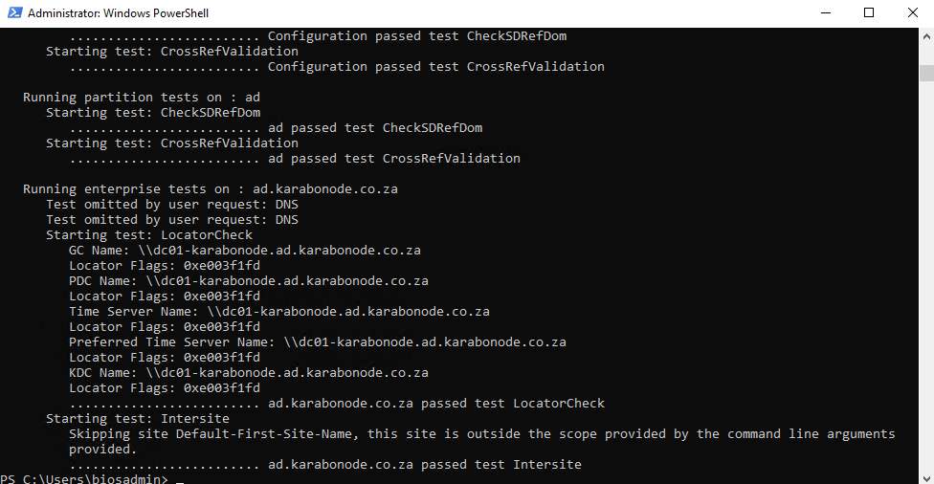
Get-ADDomain
is a PowerShell cmdlet used to retrieve information about the Active Directory domain your machine is connected to.
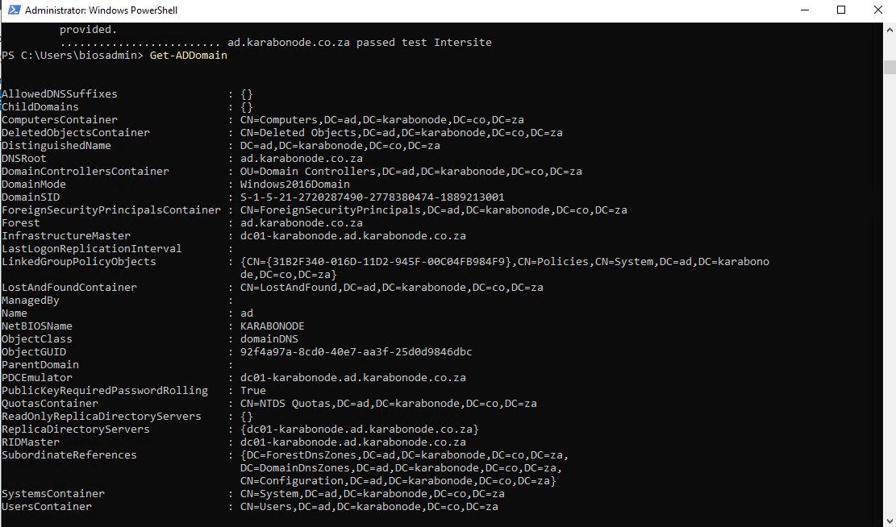
Get-ADForest
is the PowerShell cmdlet that retrieves information about the entire Active Directory forest.
